Nada Mohamed-Aly

Ms. Gerstein

Tech 9/10

17 June 2013

Individual Project Summary

After playing the game that my group has designed, I can honestly say I did not contribute as much as the other members did. As Graphic Designer/ User Interface Designer, I was in charge of creating the characters that we would use for the game and coding the user interface. In our game, the player is first directed to click the mouse to begin the game by on screen instructions. Then, using the right and left arrow key, the player must guide the character as it jumps from platform to platform. My direct responsibility was creating the beginning screen and the following screens that displayed when a player cleared a level of platforms. I was also responsible for creating all three characters that the player would use.

In designing the characters, I used paint and photoshop to create three different characters: a farm boy, an angel, and a ghost. These images are pictured here:

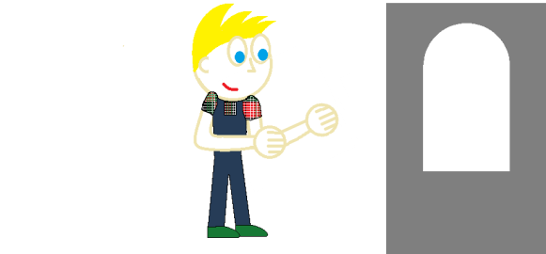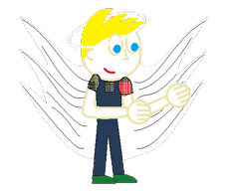

However, when we got around to including the characters into the game, we determined that it would be more difficult to use pictures rather than coded images. So the above images were scrapped and in its place, three new images were used. These images resembled the Bloo from Fosters Home for Imaginary Friends character I made for a previous processing project we completed in class. Ultimately, we coded a ghost, bloo, and bloo as an angel with a halo.